Science Quest 8
Chapter 9: Sedimentary, igneous and metamorphic rocks
Testmaker 9.3

 | Which two of the following are common igneous rocks?  - Pumice  - Quartz  - Basalt  - Sandstone | A and C | 2
 | A sample of obsidian has no visible crystals because it:  - is not an igneous rock.  - was not made from crystalline substances.  - cooled too quickly when it was formed.  - was formed by volcanic eruption, under temperatures too high to allow crystals to form. | C | 1
 | You have found a piece of rock that contains three different coloured crystals: black, white and grey. The crystals in this rock are large. This rock sample is most likely to:  - be granite.  - be extrusive granite.  - have cooled quickly.  - be obsidian. | A | 1
 | Rocks such as pumice have many holes in them. How are these holes formed? | They are formed by gases that are trapped in molten lava as it cools. | 1
 | A rock formed below the surface of the Earth is referred to as being:  - intrusive.  - extrusive.  - obtrusive.  - a monolith. | A | 1
 | Why do intrusive rocks generally have larger crystals than extrusive ones? | Because they form beneath the ground, taking longer to cool. This allows larger crystals to grow. | 2
 | What is the main difference between intrusive and extrusive rocks? | Intrusive rocks are formed below ground; extrusive rocks are formed above ground. | 2
 | Describe basalt and how it forms. | Basalt is a dark-coloured rock formed when lava cools quickly on the ground or under the ocean. | 2
 | Which statement best describes the process of deposition?  - Magma flows over the surface of volcanoes.  - Sediments are laid down in horizontal layers.  - Snow settles on the ground.  - Sedimentary rock is changed by heat to metamorphic rock. | B | 1
 | Which of the following is an example of chemical weathering?  - Water evaporating from salt lakes to form rock salt  - Waves breaking up coastal rocks into smaller pieces  - Acid rain dissolving the cementing material of sedimentary rocks  - Wind blasting rocks with sand grains and wearing the rocks away | C | 1
 | Shale is formed from:  - sediments deposited in fast-moving water.  - grains of different sizes.  - fine grains deposited in calm water.  - the remains of dead plants. | C | 1
 | Chalk and limestone are both formed from the remains of dead organisms. Explain why limestone is suitable for cladding buildings while chalk is not. | Limestone is much harder than chalk; chalk is very brittle and would wear away very quickly. | 1
 | Which of these rocks are formed mainly by heating while under pressure?  - Quartzite  - Slate  - Granite  - Marble  - All of the above | A and D | 2
 | The following diagram shows a number of layers of sedimentary rock taken from a road cutting.    Under what circumstances would layer A be the oldest rock layer? | Extreme seismic events can lead to the ‘flipping’ of rock sections. The rock section is uplifted, fractured and redeposited. | 1
 | A palaeontologist studies:  - rocks.  - insects.  - fossils.  - volcanoes. | C | 1
 | A dinosaur footprint is an example of a:  - cast fossil.  - fossil.  - trace fossil.  - carbon imprint. | C | 1
 | Why are fossils unlikely to be found in igneous rock? | Remains are unlikely to survive the extreme heat that forms igneous rocks. | 1
 | Which type of fossil would most likely provide the best information on how quickly a dinosaur moved?  - Dinosaur skeleton  - Footprints  - Leg bones  - Droppings | B | 1
 | Ectothermic means:  - the body temperature depends on the economy.  - the body temperature varies with that of the surroundings.  - the internal temperature of an animal.  - the body temperature is constant. | B | 1
 | Describe two causes of weathering. | Answers will vary but may include wind and acid rain. | 2
 | If you look at a sample of soil under a magnifying glass, what are you likely to see? | Weathered rock and decayed plant and animal material | 2
 | Draw diagrams that explain the difference between conglomerate rock and sandstone. (Hint: Think about the grains in each type of rock.) | 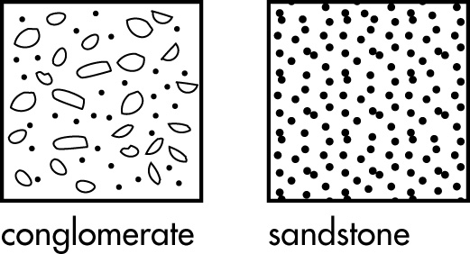 | 2
 | Give two factors that affect the formation of metamorphic rocks. | Answers will vary but may include: type of rock, amount of heat, amount of pressure and rate of change. | 2
 | Describe two ways that fossils may be formed. | Answers will vary but may include:  - hard parts of plants and animals preserved or altered by chemicals/minerals  - objects trapped in sap  - impressions of objects and footprints. | 2
 | Suggest one reason why we have not found a fossil of every living creature that has ever existed on Earth. | Answers will vary but may include:  - Some organisms did not live in an area of sedimentary rock formation.  - We have yet to discover their fossils. | 1
 | Under what circumstances might we find fossil remains of an organism that include the soft-tissue parts as well as hard structures like wood and bone? | Answers will vary but may include:  - insects trapped in sap that hardens (amber)  - entire organisms are buried in ice and preserved. | 1
 | What may have happened long ago that produced the pattern of dinosaur footprints shown?  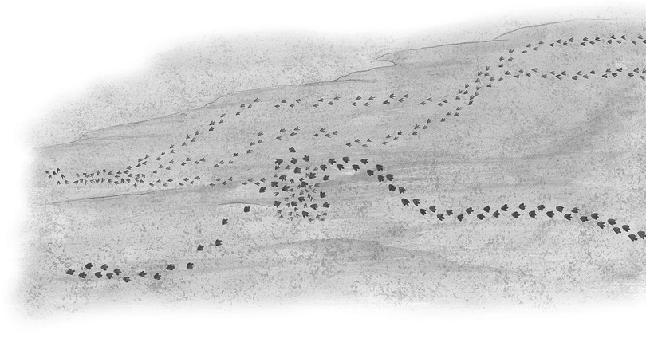 | Answers will vary but may include:  - A larger dinosaur has tracked down and eaten a smaller one. | 1
 | How could an asteroid wipe out all dinosaurs if it hit only a very small section of the Earth’s surface? | Billions of tonnes of dust would have been thrust into the atmosphere, blocking the sun, causing plant growth to slow or cease, and lowering the temperature of the Earth’s surface. These effects could have killed the dinosaurs. | 1
 | While on an archaeological expedition, you discover a fossil from the era of dinosaurs.  Describe your find, and suggest events that led to the formation of the fossil. | Answers will vary. | 3
 | Which theory on the disappearance of the dinosaurs do you support? Give reasons. | Answers will vary. | 3
 | Construct a fishbone diagram to show possible causes for the death of a woolly mammoth that became a fossil. | Answers will vary. An example is given.  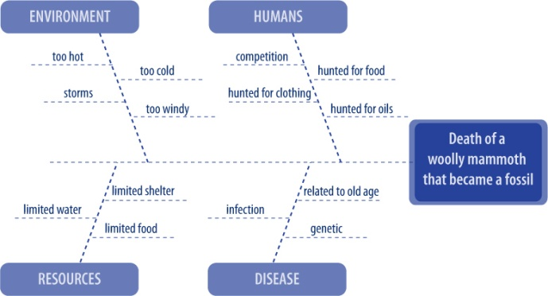 | 5
 | Explain how you could test the effect of fast or slow cooling on crystal growth as a liquid solidifies. | See investigation 9.2 ‘Does fast cooling make a difference’ on page 281 of Science Quest 8. | 3
 | Construct a mind map of three types of igneous rock (e.g. pumice, granite and basalt). | Answers will vary. An example is given.  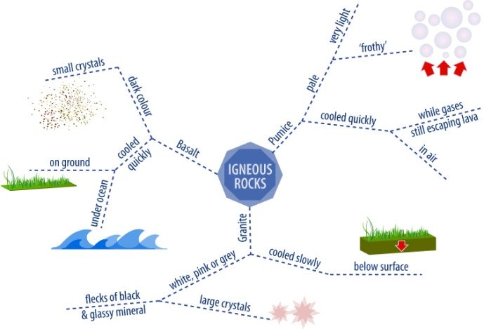 | 5

